- Resolve Merge Conflicts
- Create a merge conflict intentionally (two users editing the same line).
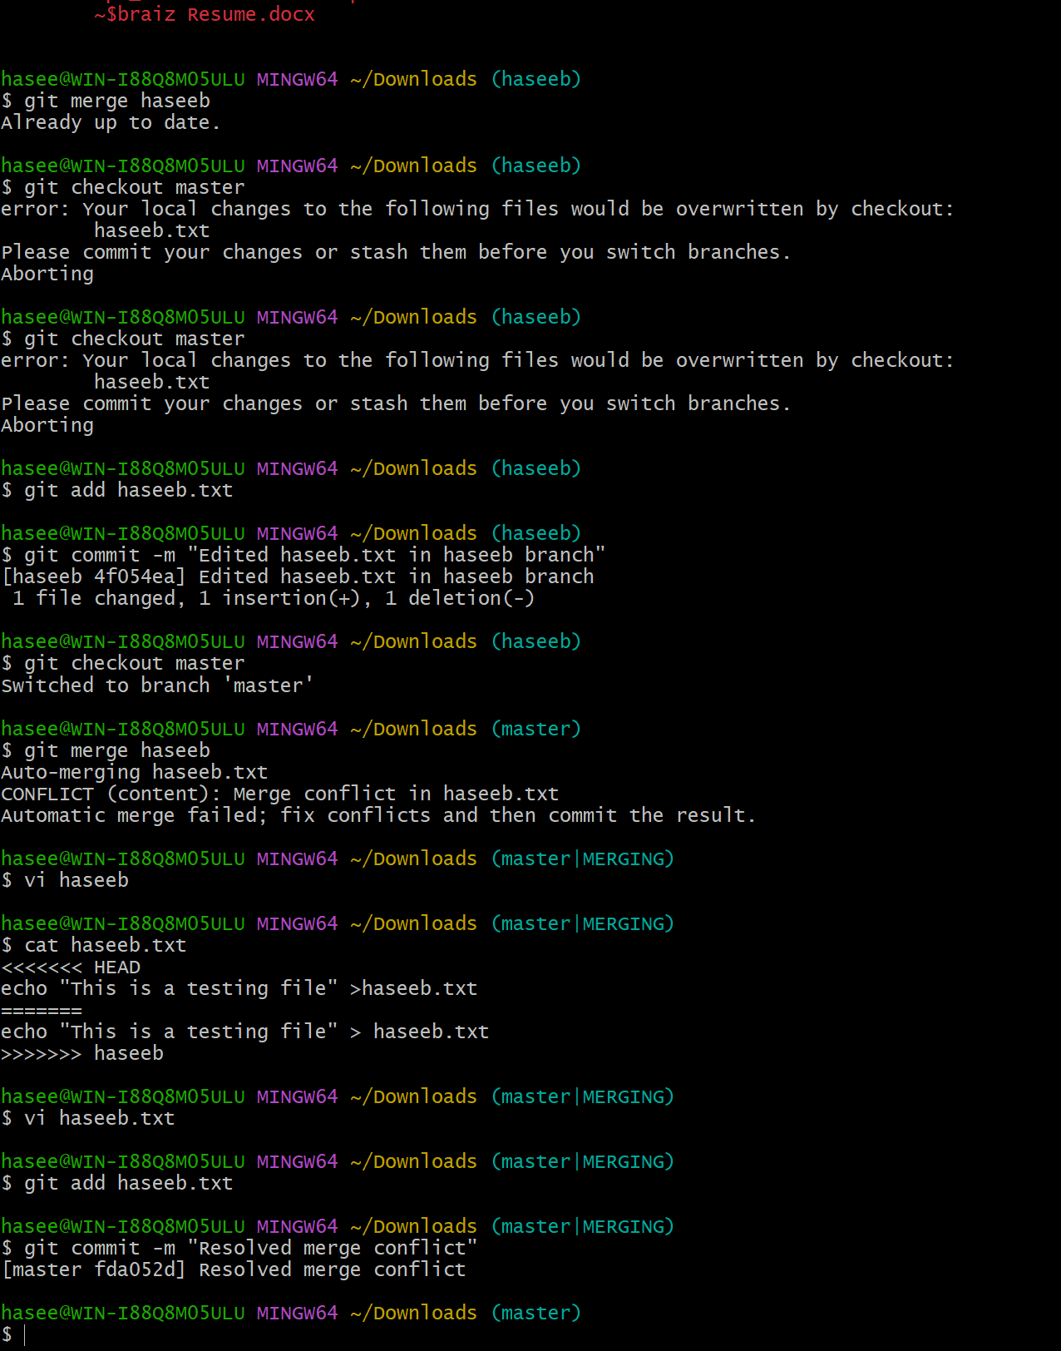
Resolve the conflict and push the changes.
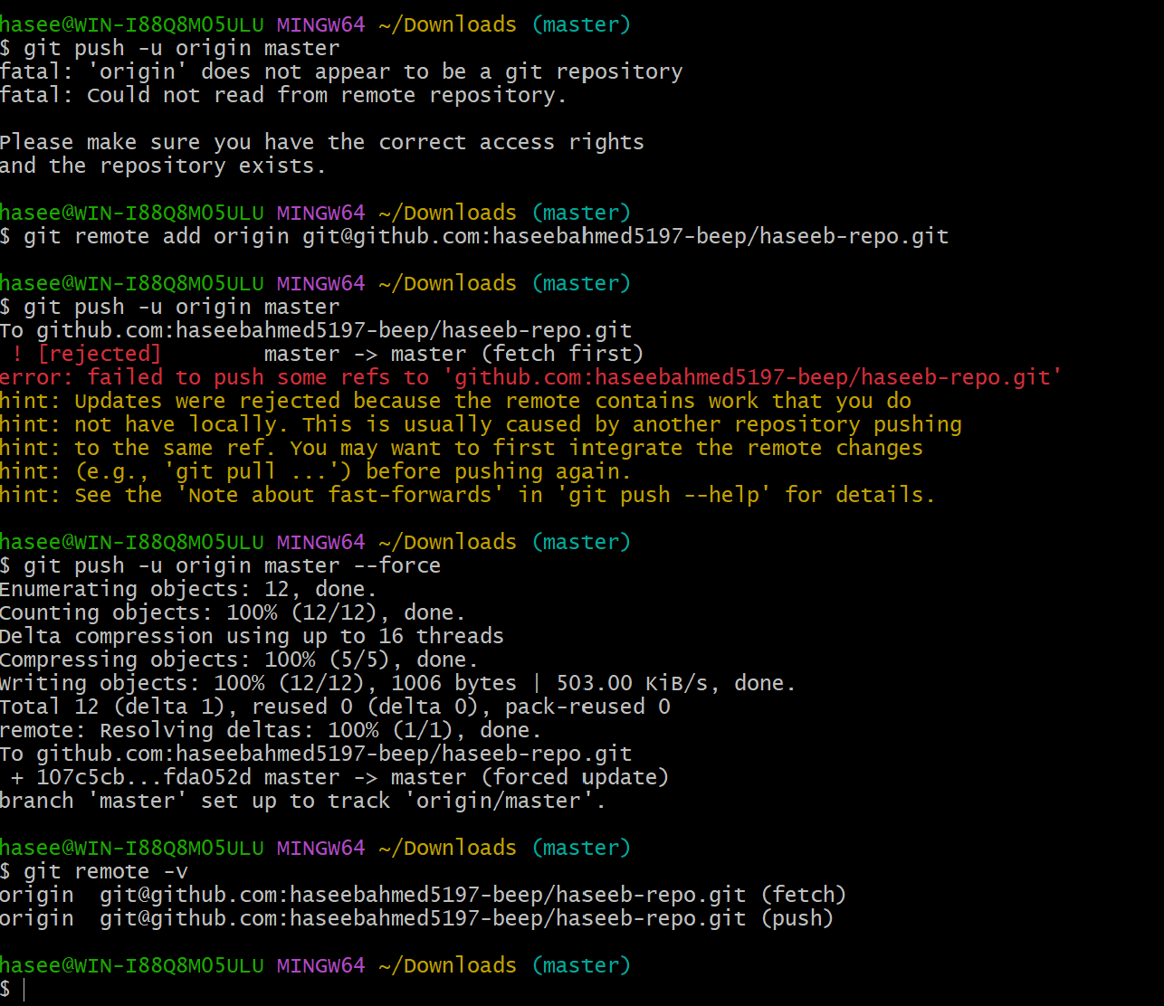
Recover Deleted Branch & Delete a local branch and then recover it using the reflog.
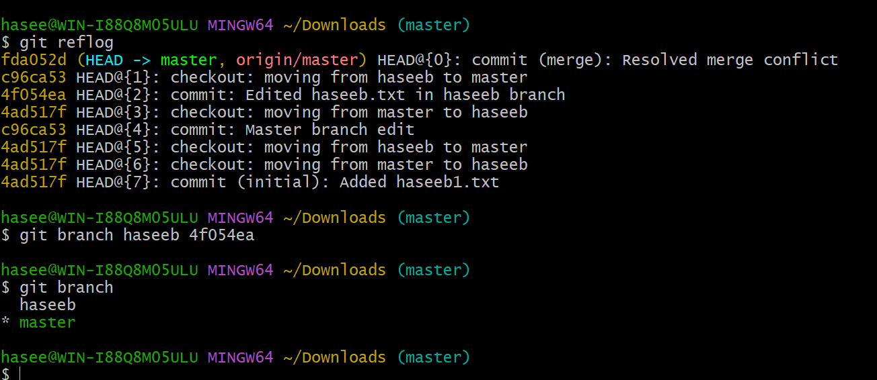
Undo Wrong Push
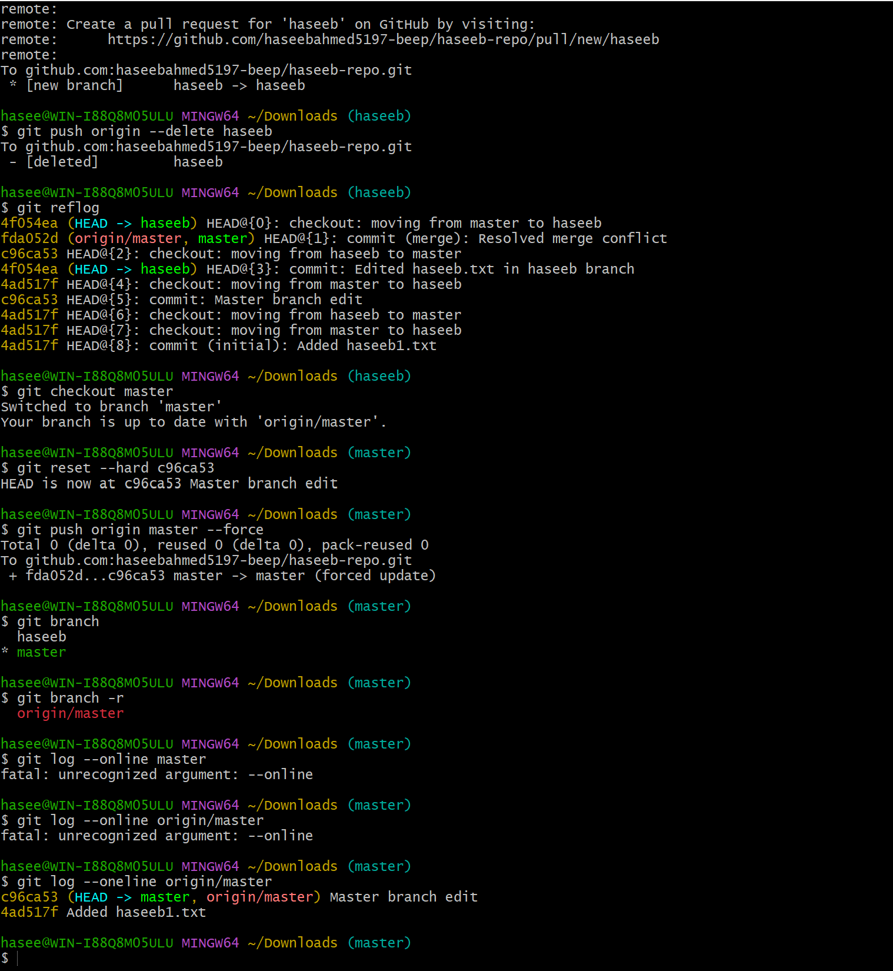
Push a wrong commit to GitHub, then undo it without losing history.
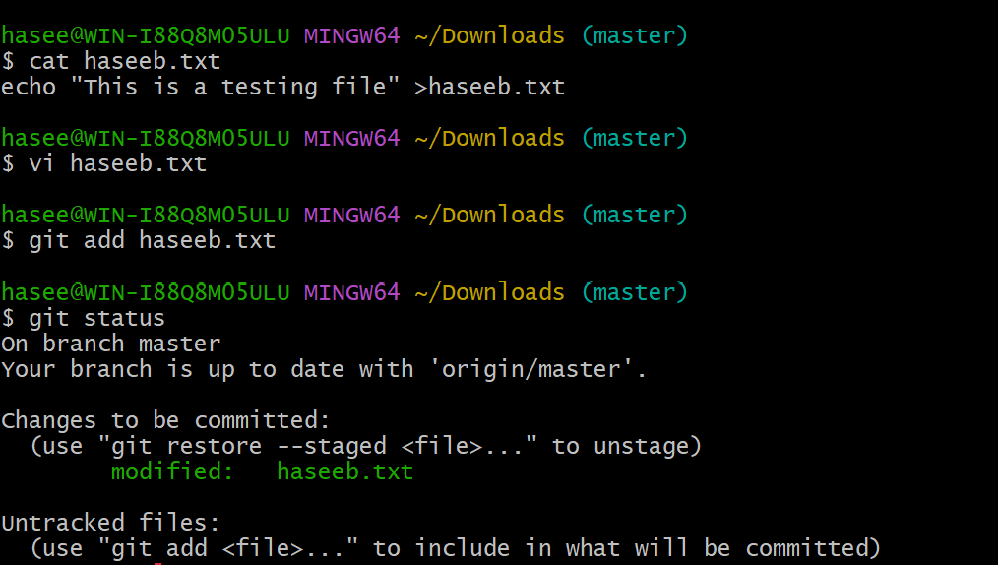
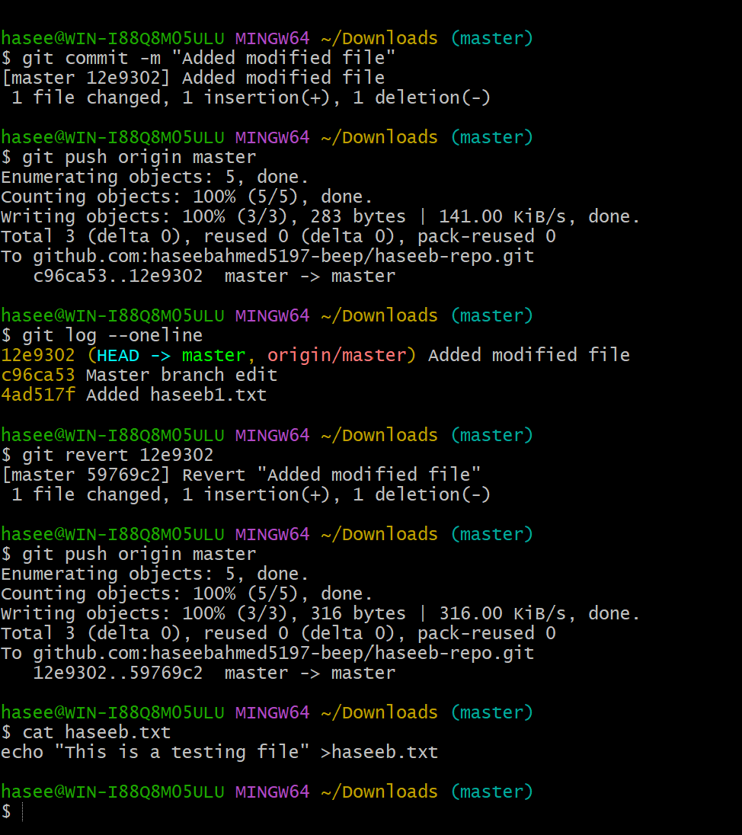
Amend a Commit
- Make a commit, then add a missing file to it using git commit --amend.
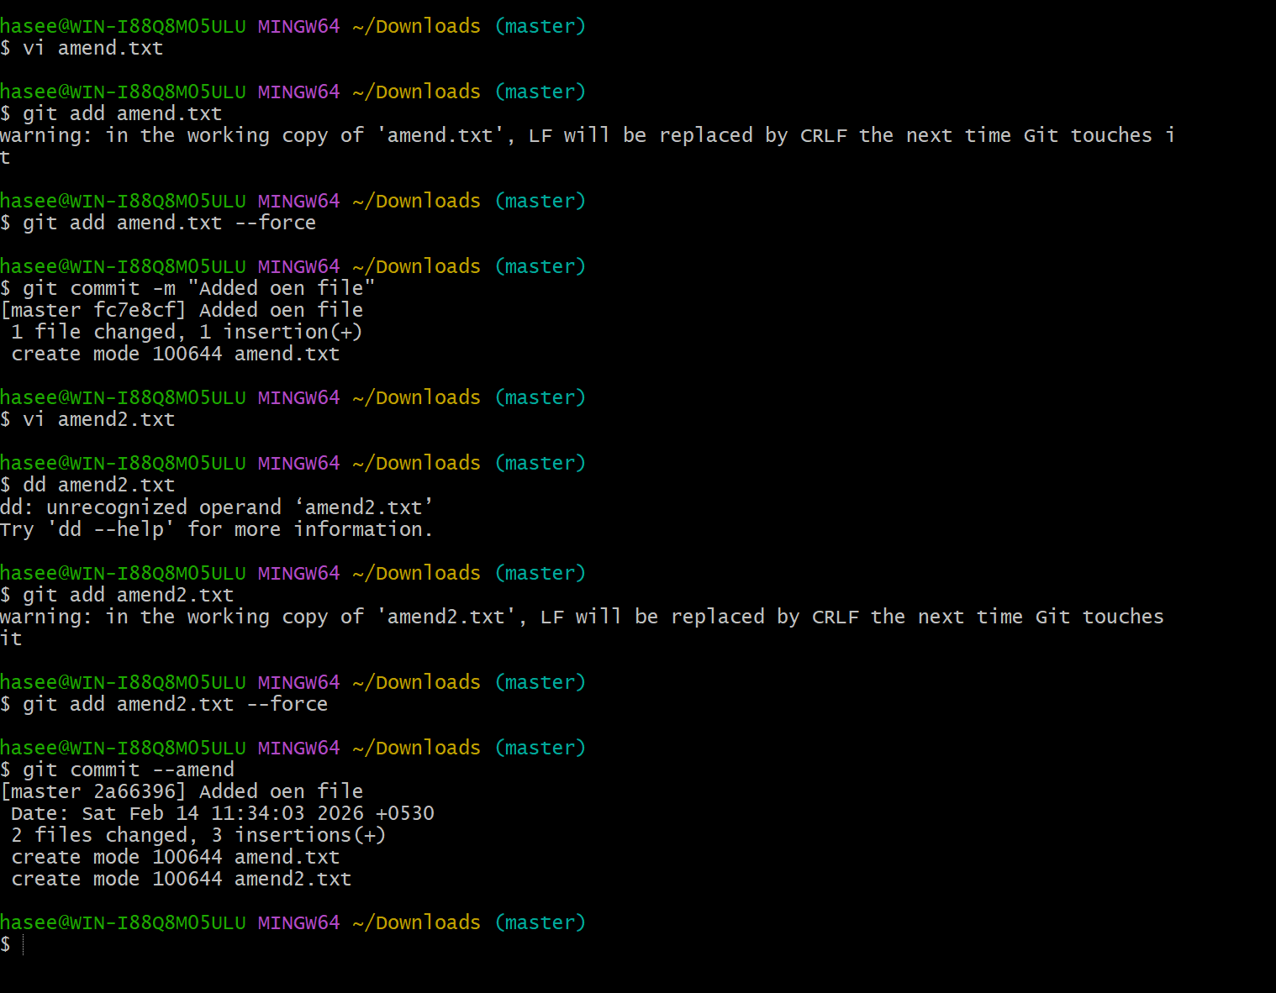
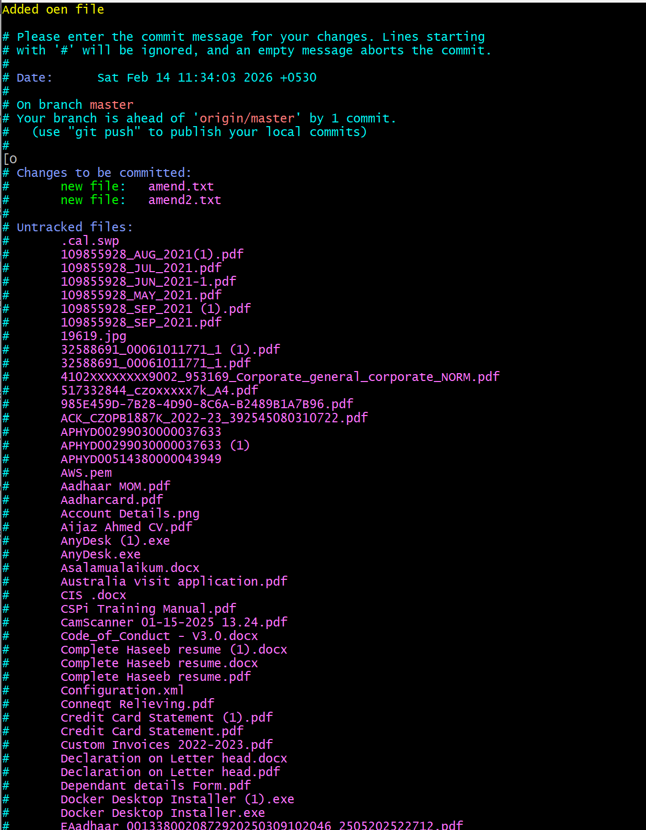
Cherry-pick a Commit
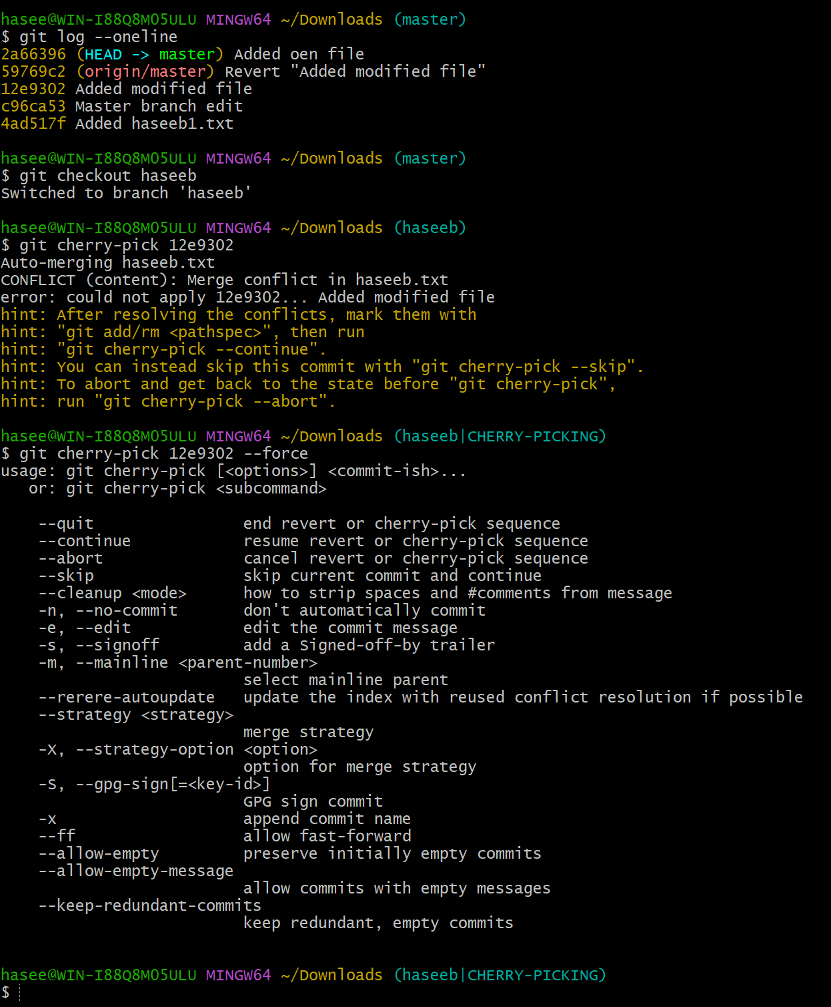
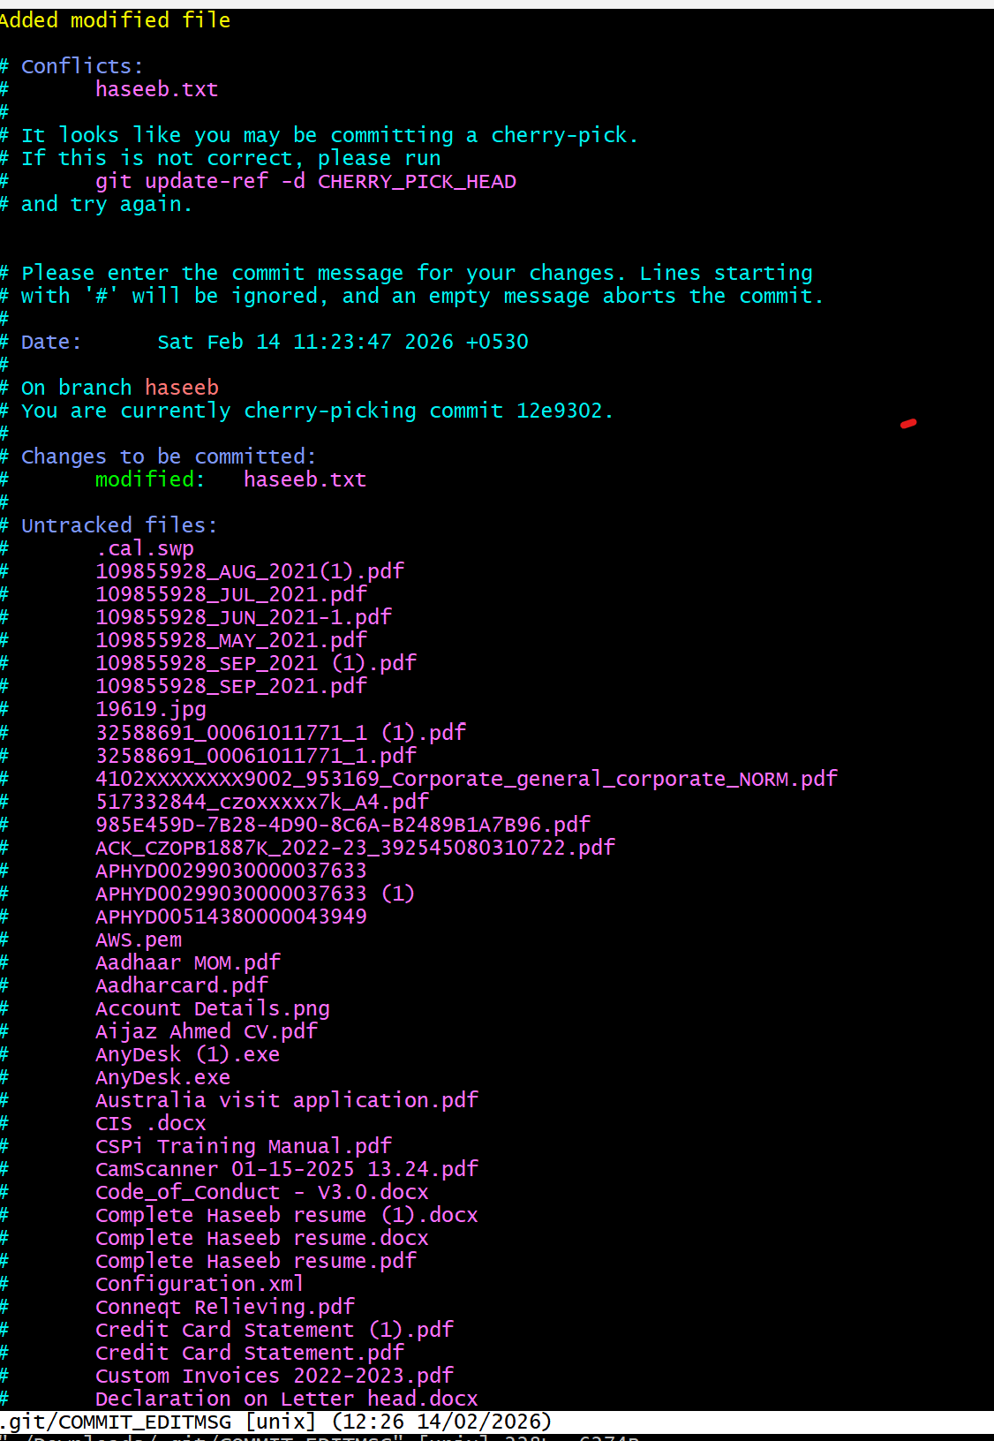

Take a specific commit from one branch and apply it to another branch.
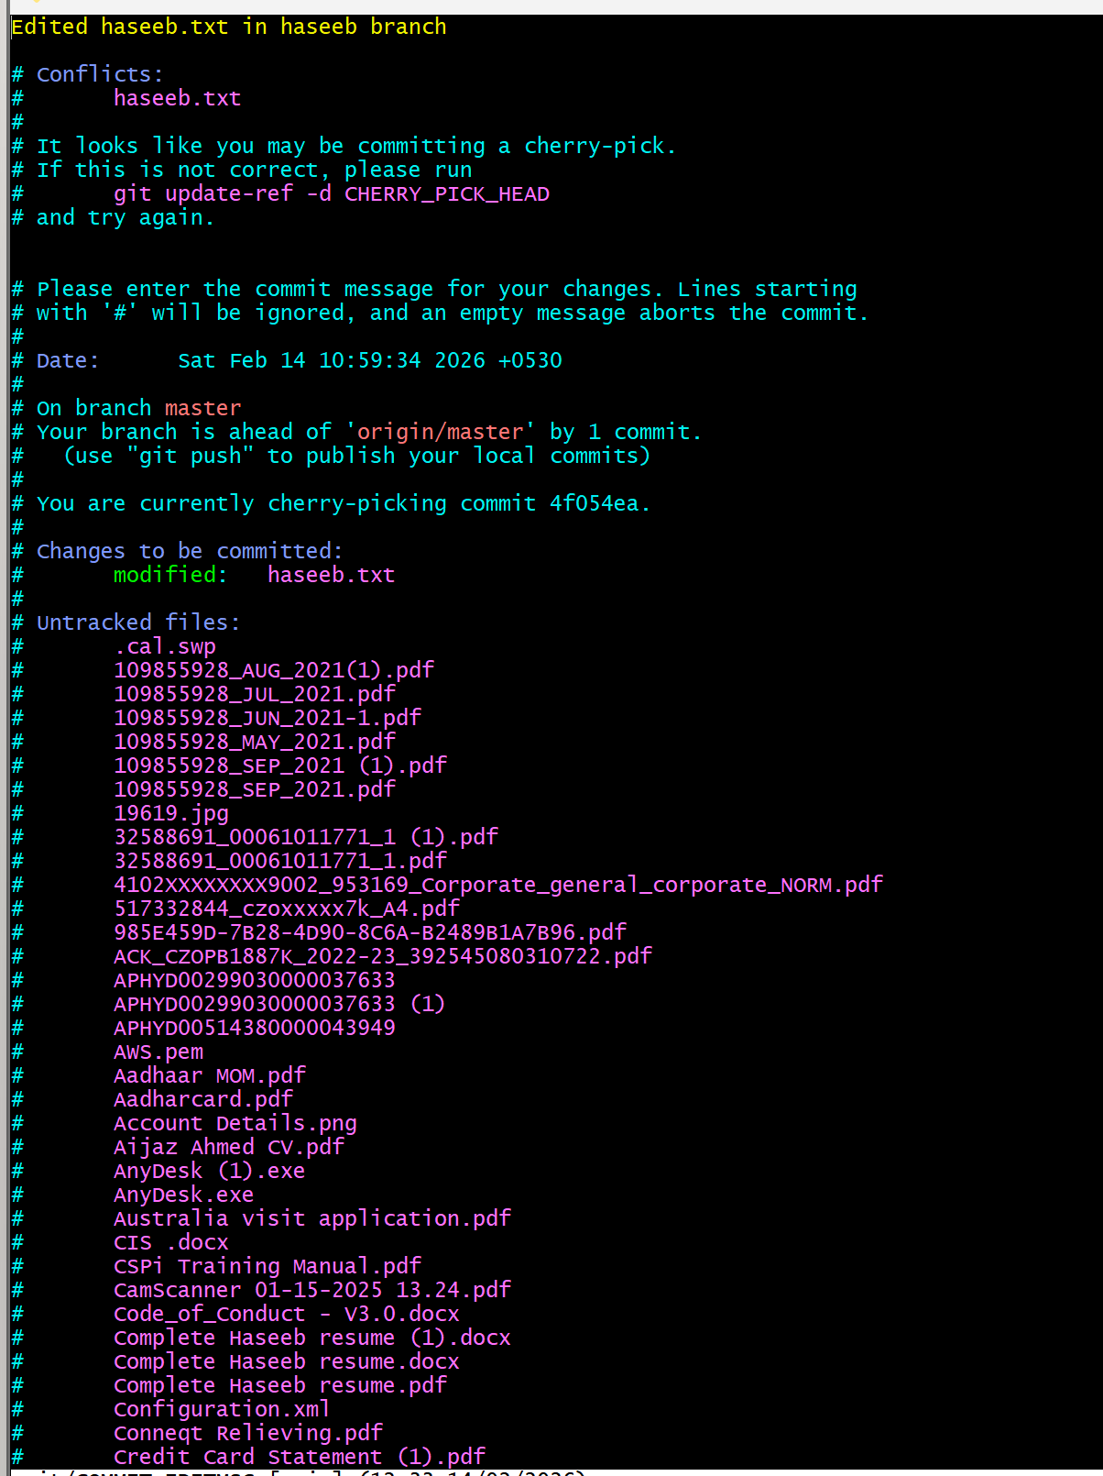
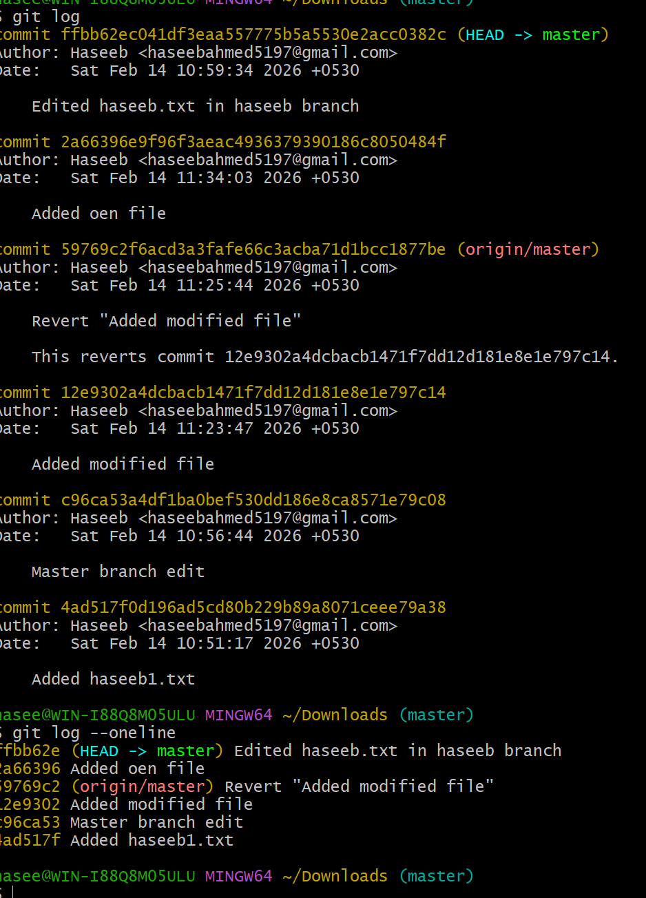
Interactive Rebase
Reorder and squash multiple commits into a single clean commit.
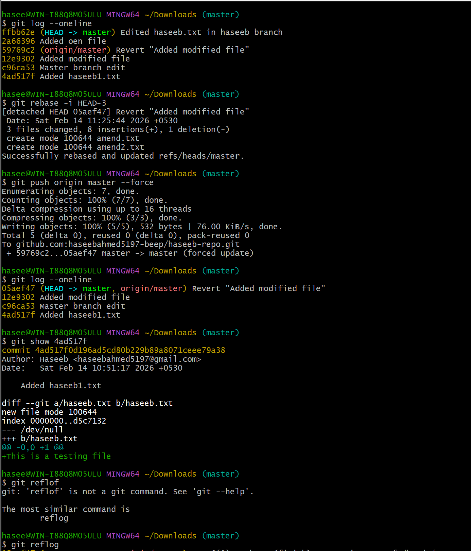

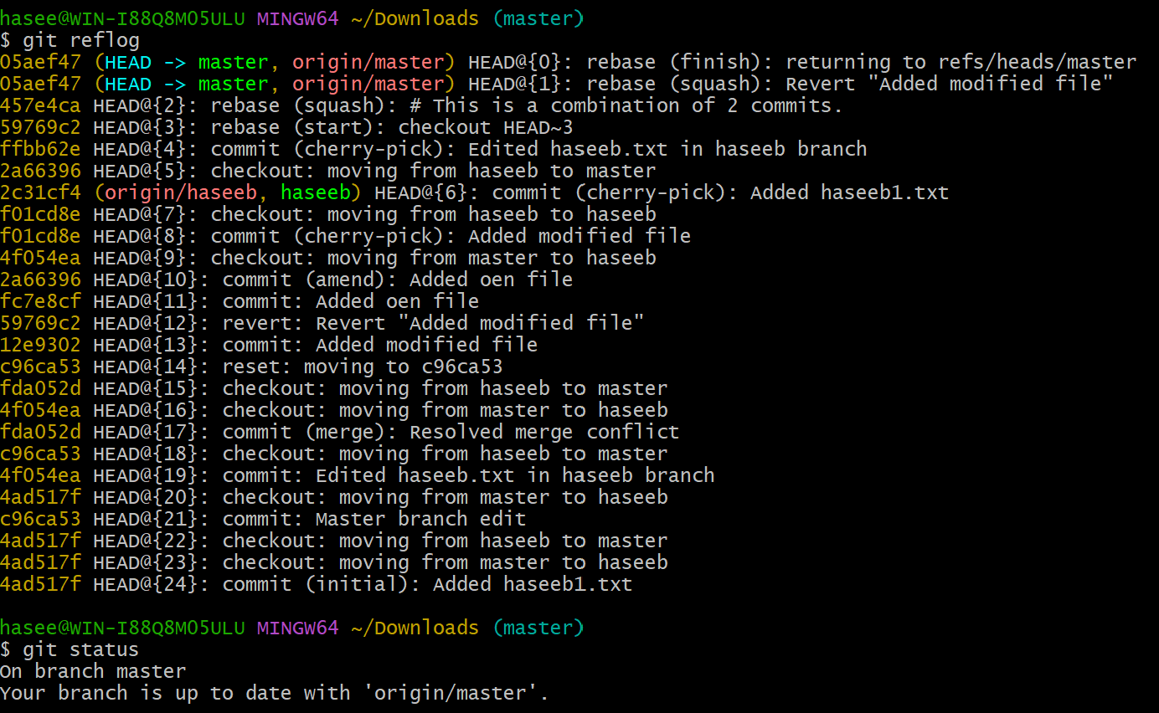
Tagging & Release
Create a version tag (v1.0), push it to GitHub, then delete and restore it.
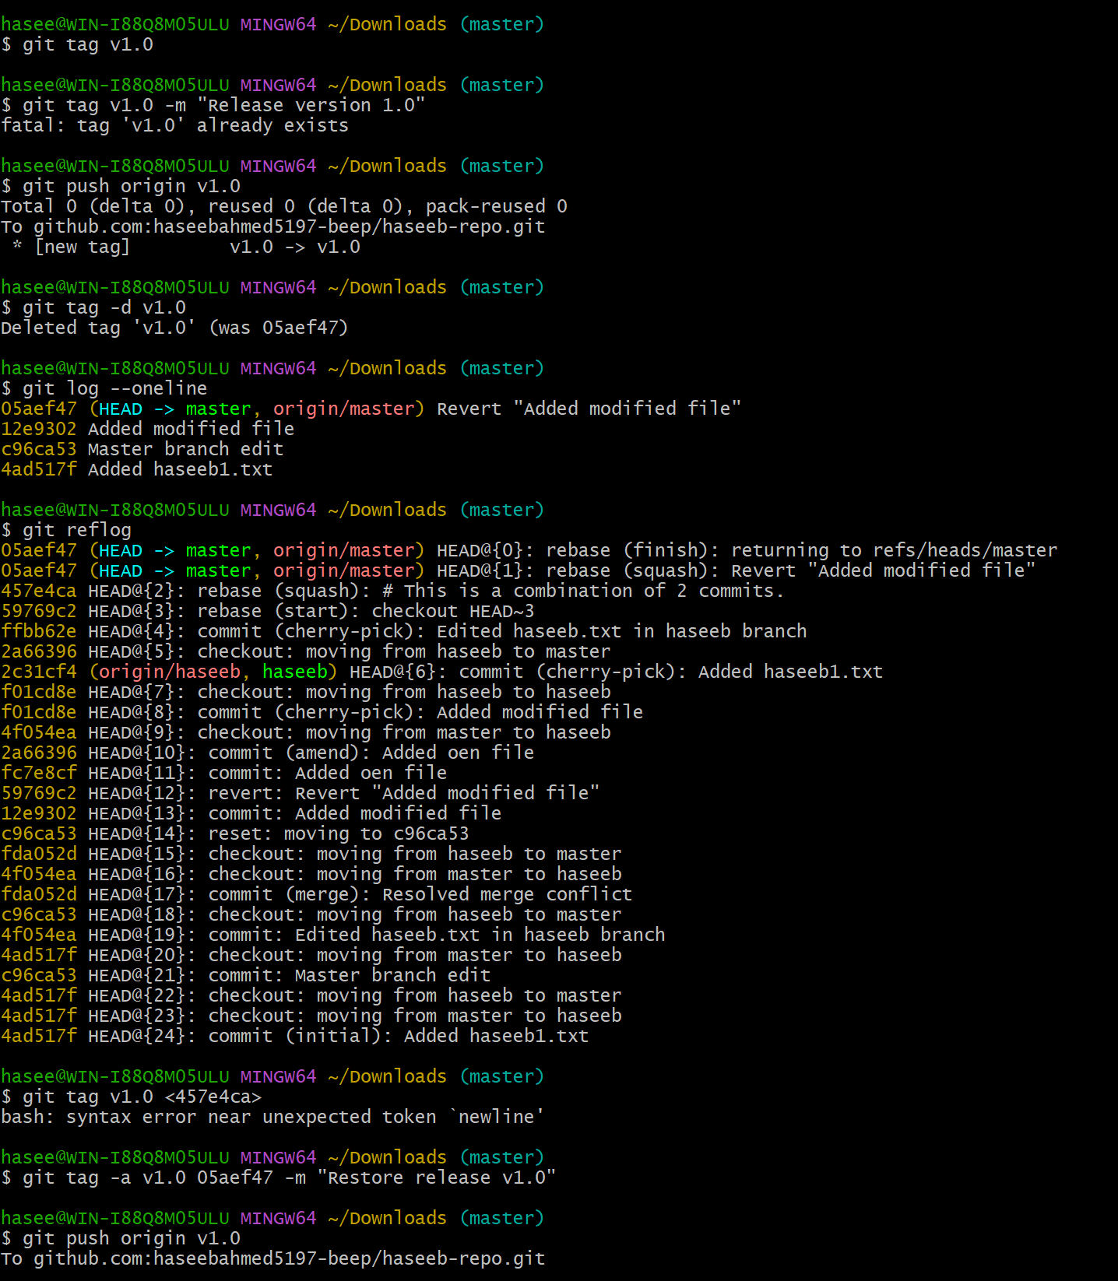
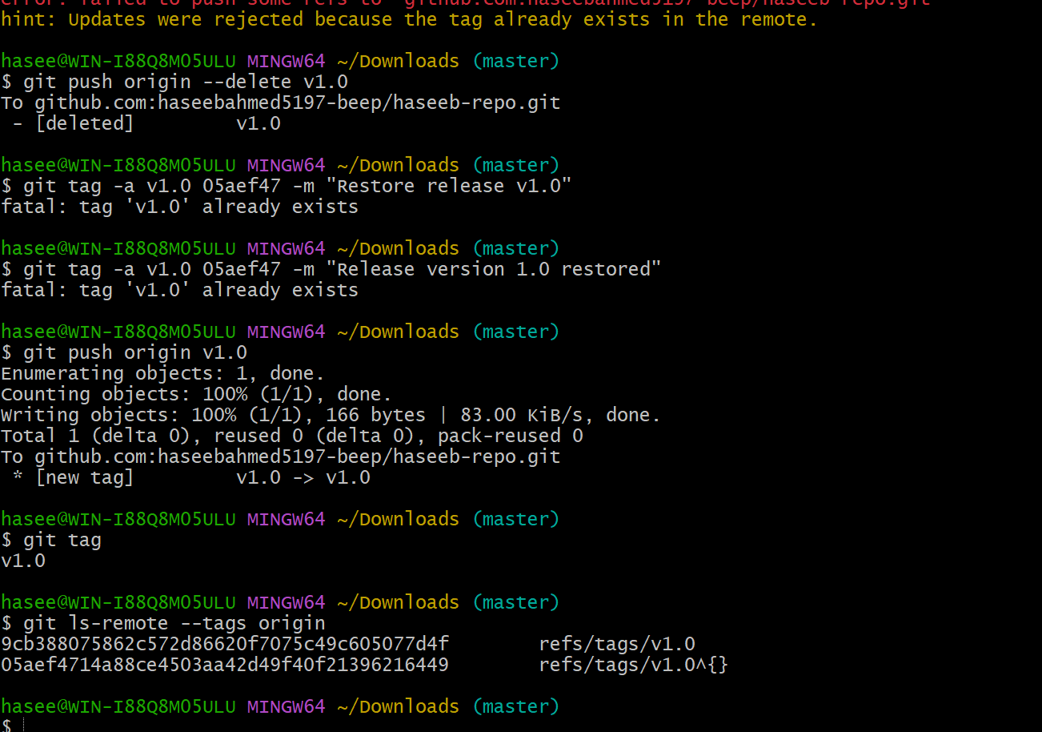
Clone with Sparse Checkout
Clone only a subdirectory of a repo using sparse checkout.
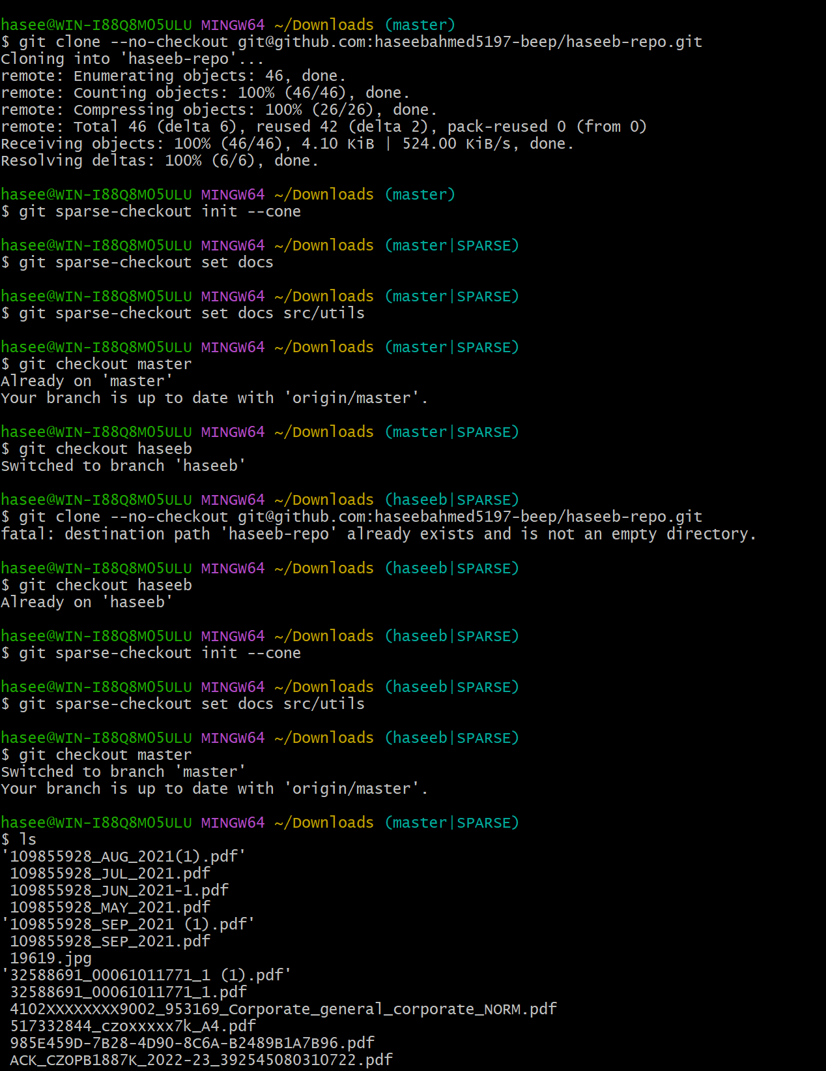
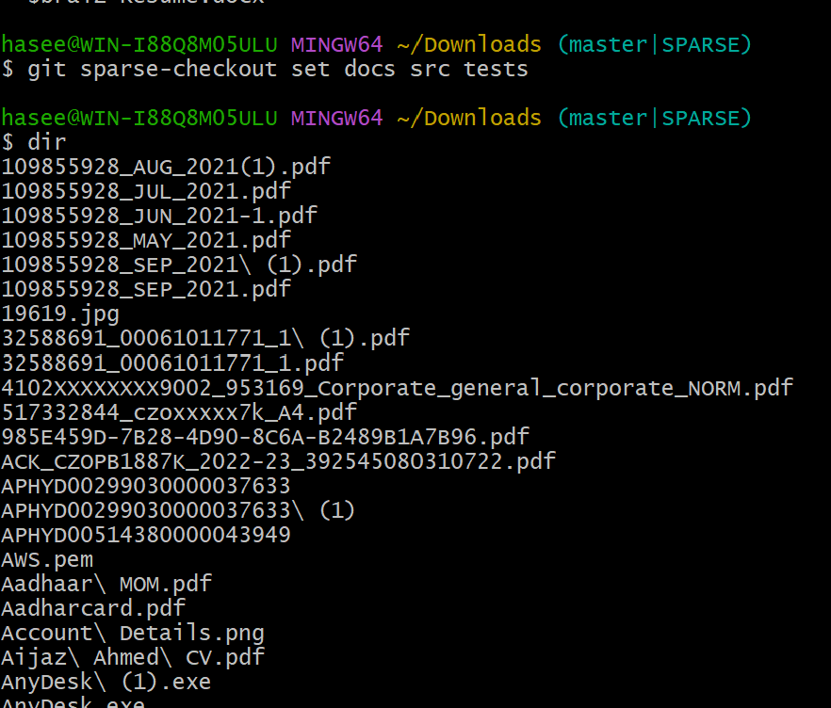
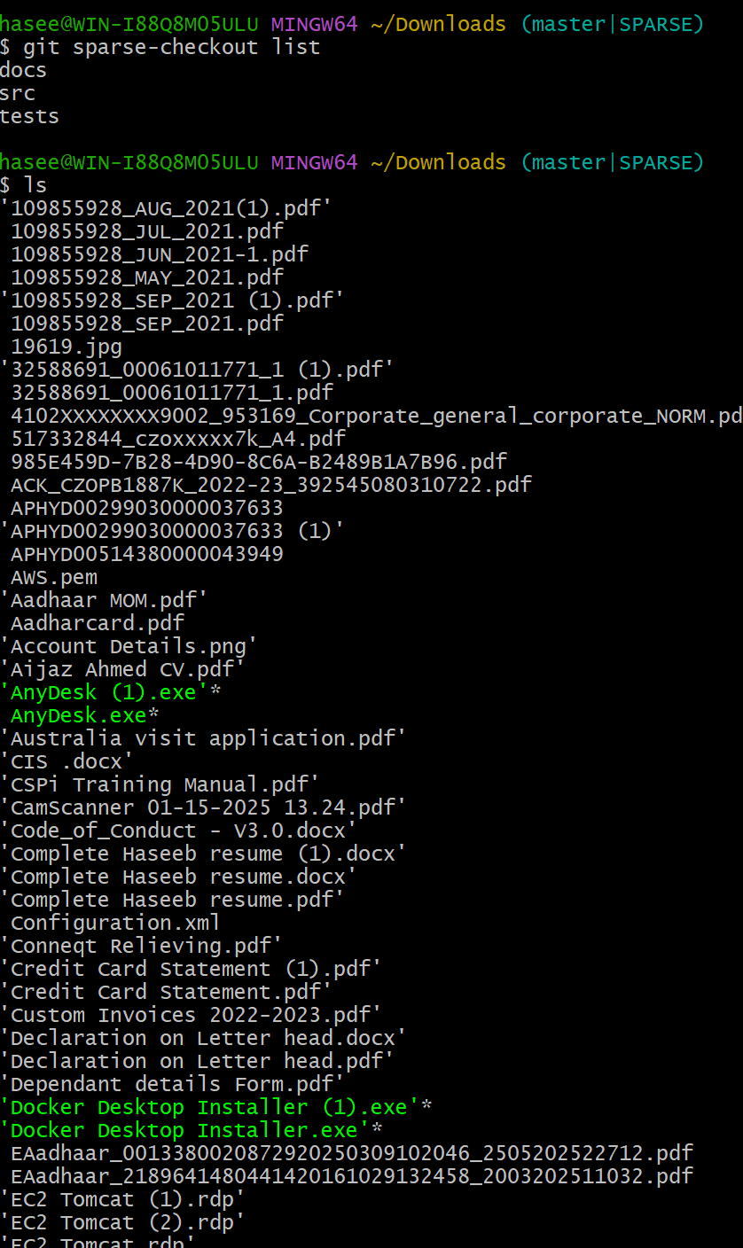

Reset vs Revert Challenge
Demonstrate the difference between git reset --hard and git revert in a repo.
Reset
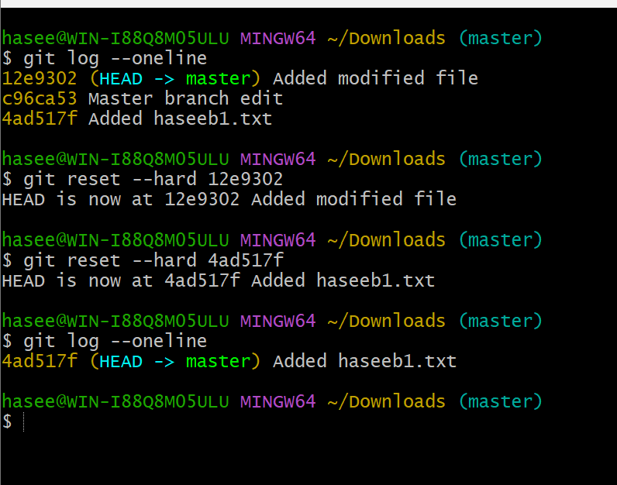
Revert
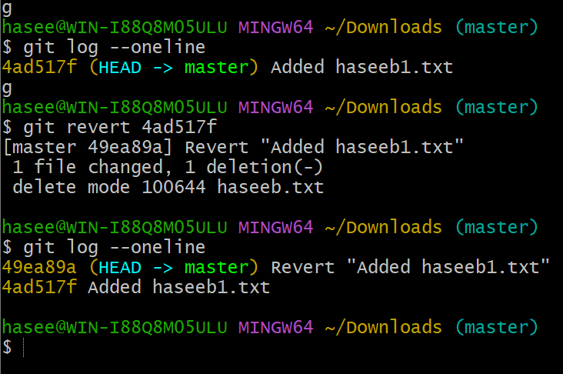
Detached HEAD Challenge
Checkout a specific commit (detached HEAD state) and create a new branch from it.
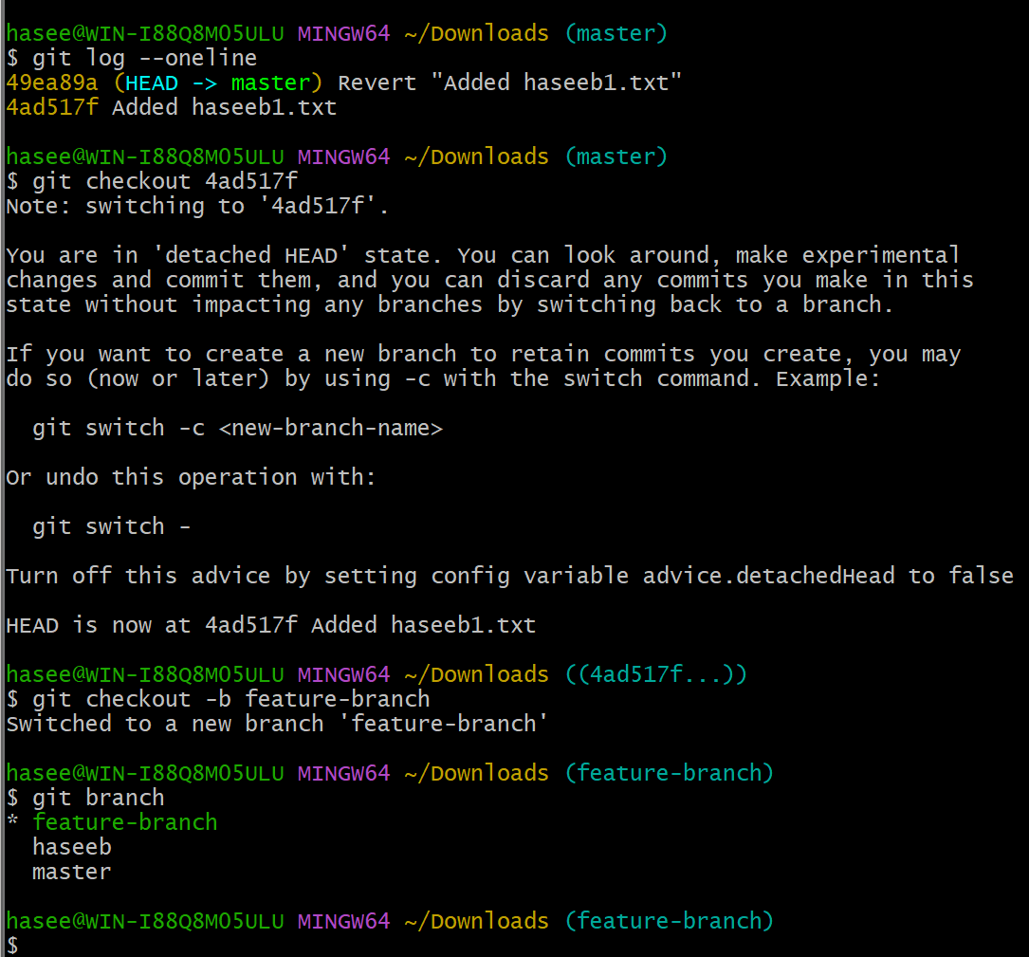
Git Hooks Challenge
Configure a pre-commit hook to reject commits without a message format (e.g., must start with jira-xxx)

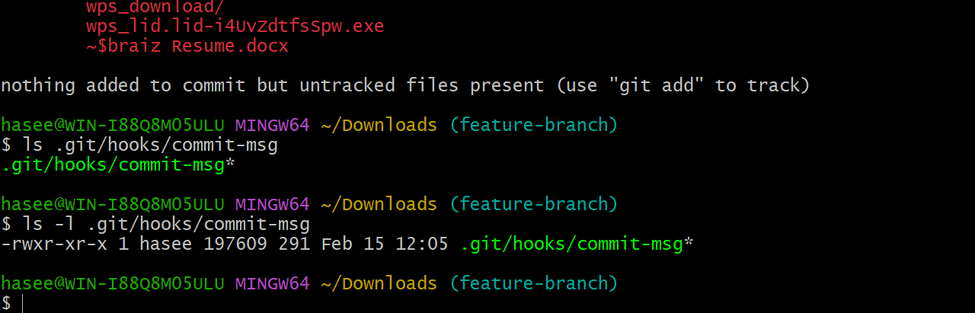

Squash Merge vs Rebase Merge
